A guide for patients – sending photographs of a rash or skin lesion

If you are phoning up with a skin problem, you may find that the receptionist staff will ask you to email in photographs of the rash/ lesion prior to the doctor or nurse phoning you. This allows the medical staff to see your skin change during the consultation and can really help us work out what is going on so we can give you the right advice and information. A good quality photograph is really helpful to getting the right diagnosis.

Below are some tips to help you get the best photographs of your skin lesion or rash:

* 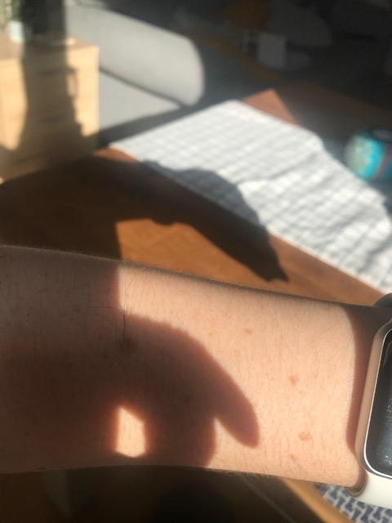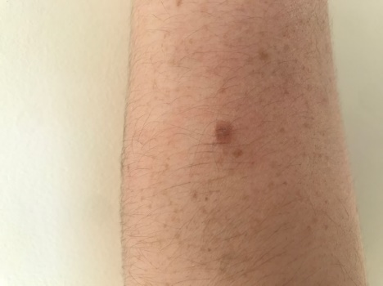Move to a bright area with lots of natural light, but avoid direct sunlight. Otherwise use an area with good overhead lighting. You want the light source to be shining on or at the side the skin, with no shadows. Ideally have a plain background.
* 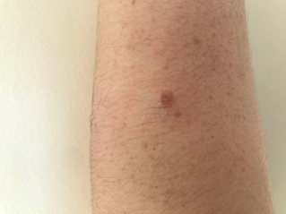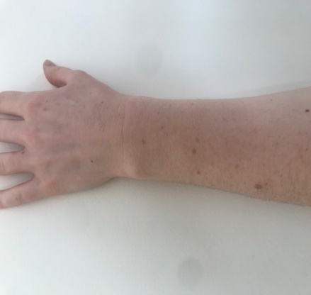Always take at least 2 images, one that is more zoomed out to help us see where it is on the body and its pattern and a close up image to allow us to see the changes in more detail. If the lesion is risen, you could consider taking more photos from a different angle to help us see the depth.
* 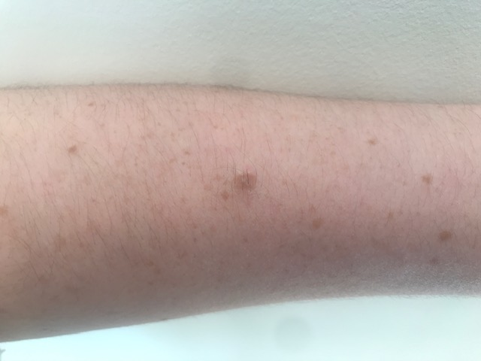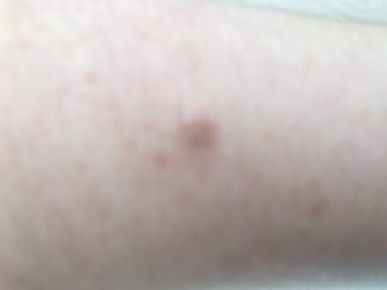It is really important it is in focus. Most smartphone cameras have an auto-focus feature and this can take a second to focus on the lesion. If you are struggling to get it focus, try moving away from the skin until it can focus.
* 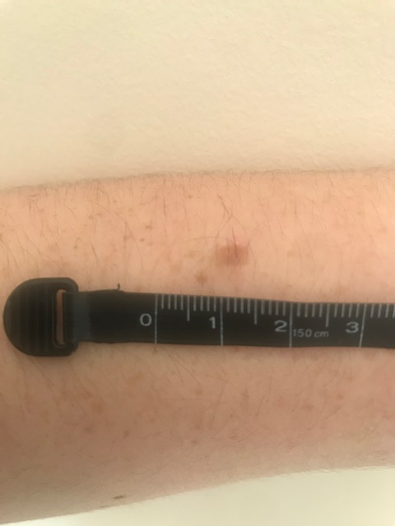If you are able, put a ruler or coin next to the lesion to help us appreciate the size (this is much easier if you have someone to assist you taking the photos)
* Review your photos prior to sending and select the best few in line with the advice above. If you are struggling to get photos please ask a family/friend to help.

We will usually store your photographs in your medical records as this is a very useful way for reviewing them in the future to assess for change. If you would rather we did not store the photographs in your medical record, please include this in your email and we will not store the images. Please do not send photos of intimate areas or any area of the body you do not feel comfortable photographing.

The email address for sending photographs is:

**Calderlea@nhs.scot**

Please only send photographs if you have an appointment to discuss your skin or have been asked to by the admin / medical staff. Please include your name and date of birth in the email message and the doctor/ nurse the photo is for the attention of.

Thank you for your assistance